

-

Artificial Intelligence Institute Africa
275 Hebert Chitepo Ave, Harare, Zimbabwe
+263 78 6434 988
admin@aiinstituteafrica.com
www.aiinstituteafrica.com


Bill To:

Date:
Organization Name:
(adress)
Phone Number:
Email Address:

Event Name(s) : AI Summit

Description  AI Summit (insert summit name) | Unit Price($) | Attendee/s | Sub-Tota($) (excluding VAT)
Total

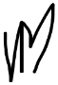
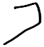
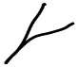
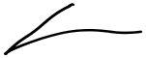
Authorized Signature (Ms. Mupikeni) AI Institute Adminstrator

Bank Name: POSB USD Account:
- Account Name: Artificial Intelligence Institute Africa

Account Number: 500008836495 Branch: POSB Main Branch, Harare, Zimbabwe Payment Terms:
- Kindly note that the Payment should made at the latest by 30 May 2026
- Please use the invoice number as payment reference

